**HR Management Dashboard**

**BUSINESS CHALLENGE**

The HR department requested some key performance indicators to track the gender diversity(M/F), full-time employee vs contractor ratio, employees by ethnic group, active employee by region employee tenure, etc.

**GOAL**

To develop a dashboard in Excel to track the human resource (HR) management key performance indicators (KPIs)

**OBJECTIVES**

* Planning
* Recruitment
* Staffing
* Gender diversity

**SOLUTION DELIVERED**

**Step1:**

**Created a mock-up of the questions to be answered on the dashboard**

* What is the total number of active employees?
* What is the total number of active female employees?
* What is the total number of active male employees?
* What is the total number of active employees by region?
* What is the total number of active new hires?
* What is the total number of active bad hires?
* What is the pay type of active employees?
* What is the total number of active full-time employees?
* What is the total number of active part-time?

**Step 2:**

**Assessed data for quality and completeness in preparation for analysis**

**Step 3:**

**Developed KPIs and performed analysis on the dataset using excel**

**KPIs**

Total active employees

Total active employees by region

Total active female employees

Total active male employees

Total active full-time employees

Total active part-time

Total hourly paid active employees

Total salary paid to employees

Total new hire active employees

Total bad hire active employees

**Step 4:**

**Created charts to graphically summarise the KPIs**

**Step 5:**

**Created final dashboard using Excel pivot charts**

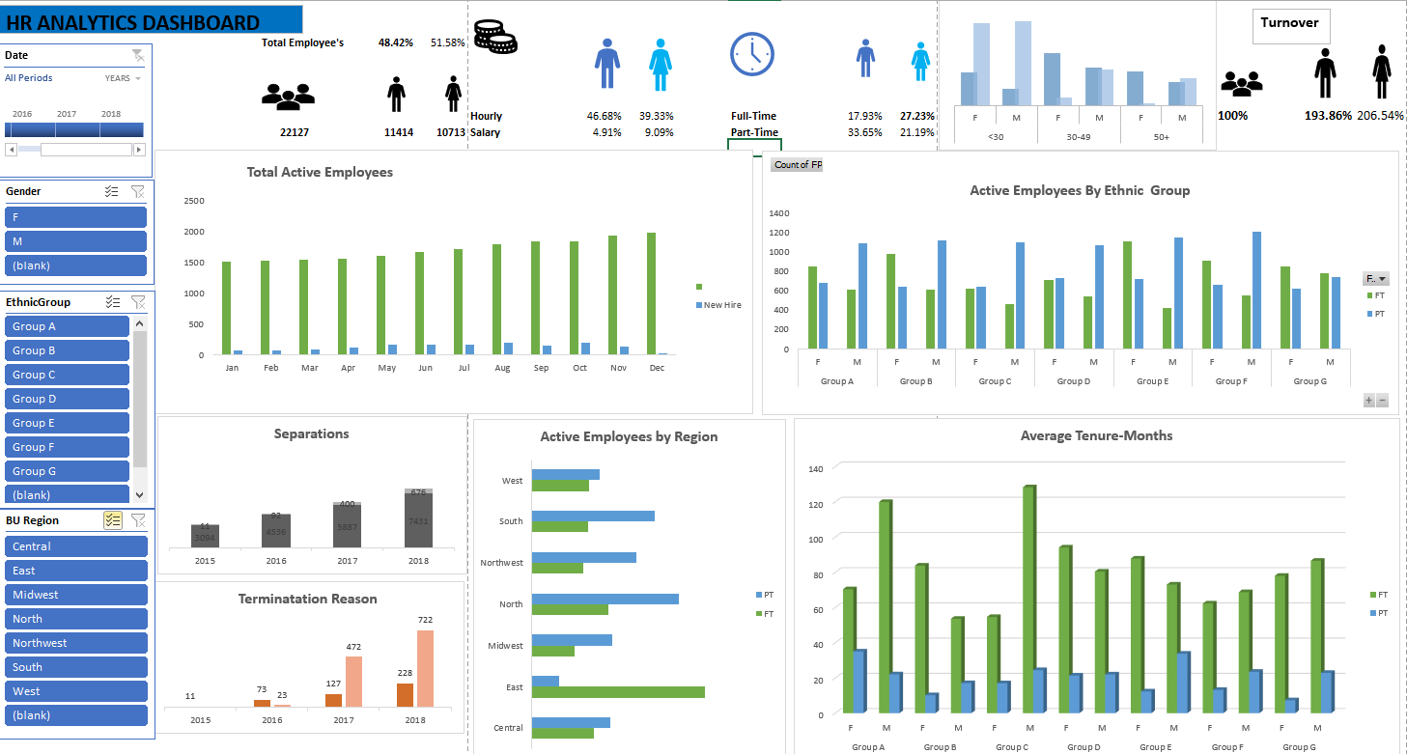

**BUSINESS INSIGHTS**

* Full-time employees have the highest number of active female employees (27.23%)
* Part-time employees have the highest number of active male employees(33.56%)
* Amongst the regions of operation, the East region has the highest number of active full-time employees and the North region has the highest number of active part-time employees.
* Amongst the ethnic group category, group E has the highest number of active full-time employees.
* For tenure, Group C has the highest number of tenures. Also, group A has a generally high number of tenures.